**ΘΕΩΡΙΑ ΣΗΜΑΤΩΝ & ΣΥΣΤΗΜΑΤΩΝ**

**ΠΛΑΤΗΣ ΕΥΑΓΓΕΛΟΣ**

**ΑΜ:2229**

**ΑΣΚΗΣΗ 1**

***k = $\left\lceil 2/3\right\rceil =1$ m= $\left\lceil 9/3\right\rceil$ = 3***

x (t)= (t cos(3πt)*u(-3π-t))+(t*sin(πt)*u(t - π))+(cos(πt)*sin(3πt)*(u(t+3π)-u(t-π)))

x1 = 3 – x(t) / 1= 3-x(t)

x2 = 2 *x(3t)

x3 = x(t - π) / 3



**ΑΣΚΗΣΗ 2**

***k = $\left\lceil 2/3\right\rceil =1$ m= $\left\lceil 9/3\right\rceil$ = 3***

**1o Ζεύγος**

x1(t)= u(t+2)-u(t-1)

y1(t)= (t+1) , (t>=-3 & t<1);

Στήριγμα y1: [-3,1)

Συνέλιξη στο [-5,2]

Περιοχή t ϵ [-5,-2]:

Περιοχή t ϵ [-2,-1]:

Περιοχή t ϵ [-1,2]:

z1(t)=

**2o Ζεύγος**

x2(t)= t * u(t+3)

Στήριγμα x2: [-3,∞)

y2(t)= e^(-3*t) * u(t-1)

Στήριγμα y2: [1, ∞)

Συνέλιξη στο [-2, ∞)

Περιοχή t ϵ [-2, ∞):

z2(t)=

**3o Ζεύγος**

x3(t)= e^((-1)*t) * (u(t+1) - u(t))

Στήριγμα x3: [-3,0)

y3(t)= u(t)

Στήριγμα y3: [0, ∞)

Συνέλιξη στο [-3, ∞)

Περιοχή t ϵ [-3,0]:

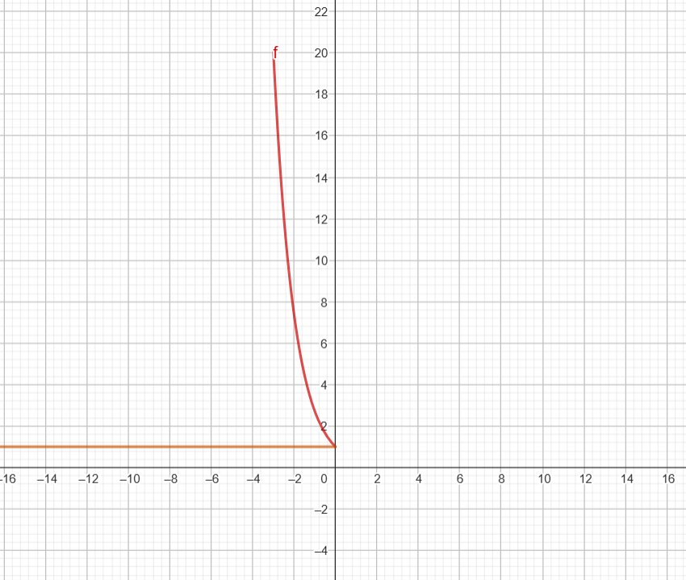

Περιοχή t ϵ [0, ∞):

z3(t)=

**4o Ζεύγος**

x4(t)= sin(t)

Στήριγμα x4: [-∞,∞)

y4(t)= e^(-3t)

Στήριγμα y4: [-∞, ∞)

Συνέλιξη στο [-∞, ∞)

**5o Ζεύγος**

x5(t)= 3(t >= -π & t < π)

Στήριγμα x5: [-π,π)

y5(t)= cos(3t)

Στήριγμα y5: (-∞, ∞)

z5(t)= 0

